YEAR 11
APPLIED INFORMATION TECHNOLOGY THEORY EXAMINATION

SEMESTER 1 12th June 2007 12.45 pm

Curriculum Council Number: __________________________

Teacher: Mr Faulks

TIME ALLOWED FOR THIS PAPER:

Reading time before commencing: Ten minutes
Working time for paper: Two hours
Multiple Choice Answer Sheet & Lined paper

INSTRUCTIONS TO STUDENTS
Write all answers in pen
Allowed pens, eraser, correction fluid/tape, and ruler.

This paper is in three (3) sections.
SECTION A: Multiple Choice. Attempt ALL questions
(10 questions = 10 marks)
Indicate your answer on the separate answer sheet.

SECTION B: Short Answers. THREE (3) questions.....
EACH MUST BE ATTEMPTED. NO CHOICE.
(3 questions = 30 marks)

SECTION C: Extended Answers.
Attempt any TWO (2) questions.
(2 questions = 60 marks).

SECTION A: Multiple Choice. Attempt ALL questions
(10 questions = 10 x 1 mark = 10 marks)
Indicate your answer on the separate answer sheet.

1. Which of the following is NOT a method of capturing graphics?

(a) Scanner
(b) Digital camera
(c) Presentation software
(d) Digital video camera

2. Which of the following graphic formats is a vector graphic format?

(a) GIF
(b) JPG
(c) TIF
(d) PCX

3. DPI literally stands for:

(a) Dots per inch
(b) Data per image
(c) Digital print icon
(d) None of the above

4. Which of the following is an area of health and safety when considering technology?

(a) E-commerce
(b) Data integrity
(c) Ergonomics
(d) Teleworking

5. Here is a URL.
http://www.ecu.edu.au/Science/index.htm

What part of the URL is the section “www.ecu.edu.au”

a) Host
b) Protocol
c) Page
d) Path
6. The source country for the URL is:-

a) United States of America
b) Australia
c) Great Britain
d) Austria

7. A web site has the URL http://www.abc.net.au/local/wa /index.html
The first word in the path is:-

a) www.
b) local.
c) wa.
d) index.

8. File names on personal computers have the format “file name.extension”. In Windows 95/98 there is no reasonable limit to the number of characters in the name, but the extension is usually limited to 3 or 4 characters with a specific format that describes the type of the file. e.g. Word files have a DOC extension. Which one of the following files is a sound file?

a) dingdong.wav
b) dingdong.shw
c) dingdong.avi
d) dingdong.mdb

9. Which of the following include extensions purely related to graphics

a) .htm, .bmp, .gif, .sys
b) .com, .bmp, .doc, xls
c) .jpg, .gif, .mov, .doc.
d) .jpg, .gif, .bmp, .tiff

10. When using audio files to insert low sound to gradually amplify to full sound, the effect to use would be?

a) fade out
b) compress
c) invert
d) fade in

END OF MULTIPLE CHOICE
SECTION B: Short Answers. THREE (3) questions.....
ALL QUESTIONS IN THIS SECTION MUST BE ATTEMPTED.
NO CHOICE. (3 questions = 3 x 10 marks – 30 Marks)

Write answer on answer booklet: Include your name and clearly identify which question and section number is being answered

- The business world is the largest user of computers and information systems. Computer systems will undergo many changes as we head into the next century. There are many trends that will affect the information systems of the next millennium. Discuss two trends from each of the following areas:

(a) Equipment
(b) Software
(c) Users

2. Unfortunately computer crime has become part of our daily lives.

(a) Explain what is meant by the term computer crime.
(b) Give three examples of different types of computer crime.
(c) Suggest two techniques that could be employed to help prevent computer crime.

3. Jodie Thorn is a graphic designer who works for a large international media design company. Jodie is a home e-worker - she works mainly from home and only goes into head office when necessary.

(a) Describe what hardware and software equipment Jodie needs and why?
(b) What are some of the advantages and disadvantages of being a home based Graphic Designer?

END OF COMPULSORY QUESTIONS
SECTION C: Extended Answers.
Attempt any TWO (2) questions.
(2 questions = 2 x 30 marks – 60 Marks)
Write answer on answer booklet: Include your name and clearly identify which of the two questions from four is being answered

- Computer Revolution
Ten years ago many ‘experts’ in talking about the computer revolution, predicted that the home would be one place where this revolution would have a significant impact. Visions of computerised homes with all kinds of electronic wizardry at one’s fingertips were conjured up and different sections of society were filled with fear, excitement or just plain curiosity.

Write a short essay that looks at this 10 year old prediction in relation to what you see as the impact of computers in the home today.

OR
- Piracy
After reading the article below, discuss the topic of “Software, Movie & Music Piracy” from a range of viewpoints.

Read the following article
From: The LA Times Newspaper, January 21, 2007 by Lou Dolinar.

"Before the introduction of the compact disc, media was analog - that is, the recording medium for what you saw or heard corresponded, in some way, to the real world. Needles bounced up and down in grooves to produce music, individual photographs gave the appearance of movement as they flickered by a lens on a strip of film.

The CD changed all that. Sound was digitized, or converted into ones and zeros. Originally designed for music, the CD was seized on by the computer industry as a storage and distribution medium for other types of digital data, primarily programs and operating systems, although PCs soon developed the ability to play back music, too.

This was when the piracy problem began. There had always been people who, for fun or profit, taped records for their own use - or resale. Computers suddenly made this process quick and convenient. Early on, a few programmers realized that there was no real obstacle to copying, or ripping, the CD to your hard drive, and playing it from there. Other programmers had developed a system for shrinking audio files with little loss in quality, MP3. As computers got faster, and hard drives got bigger, a CD could be "ripped" to disk in minutes. The copy was essentially a perfect one, due to the inherent ability of computers to check for errors in data transfers. Simultaneously, the number of people with high-speed Internet connections exploded, and services like Napster made it simple to share these ripped CDs with other people".

This piracy, however much fun it was, cost the music industry billions of dollars and destroyed the market for paid-for music among the tech savvy..."

Source: http://www.latimes.com/technology/ny-bzdolinar5059766jan21,1,2465147.column?coll=la-utilities-technology&ctrack=1&cset=true

OR

3. Work Environment
What issues need to be taken into account when considering the placement of computing or office equipment in a work environment.

OR

4. Radio Frequency Identification Device (RFID's)

Read the article below and answer the following questions.

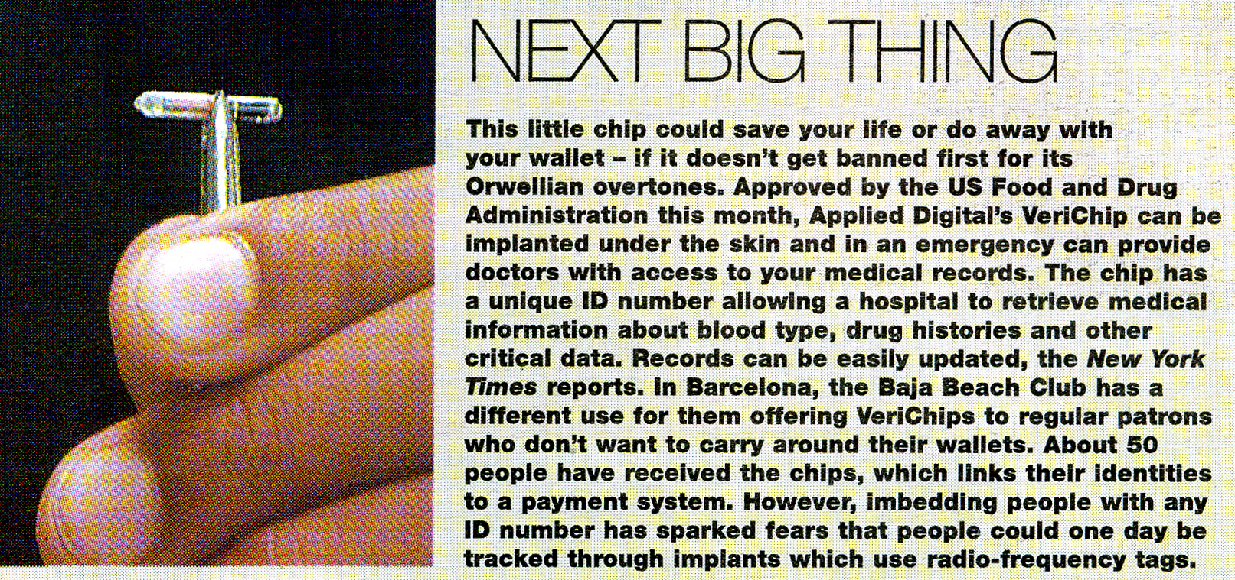

Answer any one of the following (a, b or c):

- What social implications would you consider implanted radio frequency identification device (RFID) chips would have on people that require medical treatment on a regular basis.
- On the privacy of people whom may have criminal intent.
- On any other aspect that you consider to have social implications.

END OF EXAM

